**Circulatory and Respiratory Systems**

**Content**

Structure and function of the respiratory system related to:

* gas exchange including characteristics of respiratory surfaces
* mechanics of breathing
* measurement of lung function using a vitalograph
* maintenance of concentration gradients in lungs including breathing and blood flow

Structure and function of the circulatory system related to:

* role of the heart, arteries, veins and capillaries in the circulation of blood
* measurement of heart function using a sphygmomanometer and ECG
* roles of plasma and erythrocytes in the transport of materials including oxygen, nutrients and wastes

Effects of lifestyle choices on the circulatory and respiratory systems:

* hypertension, atherosclerosis, angina, stroke, heart attack
* pneumonia, asthma, emphysema and lung cancer

**Questions from Text**

Chapter 6 Chapter 7

Review Questions: 1-12 Review Questions: 1-4

Apply Your Knowledge: 1-6 Apply Your Knowledge: 1, 2, 7 & 8

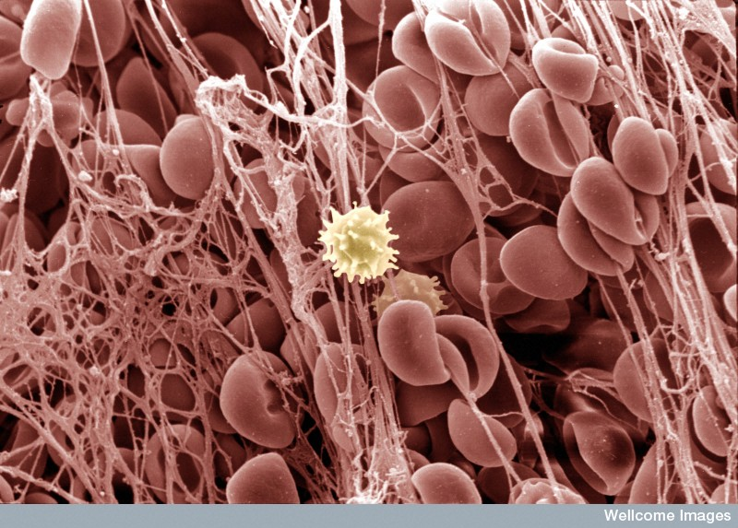

Blood clot as viewed through an electron microscope

(http://images.wellcome.ac.uk/)